**Greedy Programming**

**Document Id 45**

* Phases
* Phase k → Decision is made locally
* Phase k → local decision → global consequences ignored
* Local optimum
* Local optimum → best option at Phase k.
* Can be very efficient if work

<https://en.wikipedia.org/wiki/Greedy_algorithm>

**Implement a Greedy Solution**

1. <https://en.wikipedia.org/wiki/Line_segment>
2. Overlapping segment
3. Problem definition

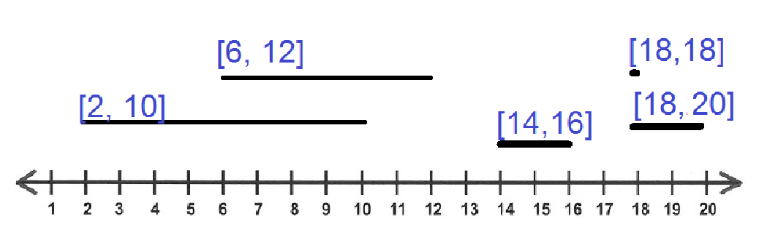

**int** segmentStart[] = {2, 6, 14, 18, 18};

**int** segmentEnd[] = {10, 12, 16, 18, 20};